# Instructions for the slot machine experiment

(At the bottom of each screen, we can add a line that says “Press right arrow key to proceed, left arrow key to go back”. Or “Press space to continue”)

### Screen 1

Welcome!

The goal of this experiment is to study how your brain encodes information when you make simple decisions.

These instructions describe what will happen during the experiment and how you will be compensated for your participation. It is important that you read them carefully.

We are very grateful for your participation in the study.

### Screen 2

What will you do during the experiment?

During the next hour, you will be asked to make about 800 decisions.

Each trial you will be asked to decide if you want to buy the right to play the slot machine shown in the screen for a price.

If you choose NO, your payoff for the trial is $0.

If you choose YES, you pay the purchase price, but also earn the random monetary prize generated by the slot machine.

### Screen 3

Each trial you will see one of these slot machines:

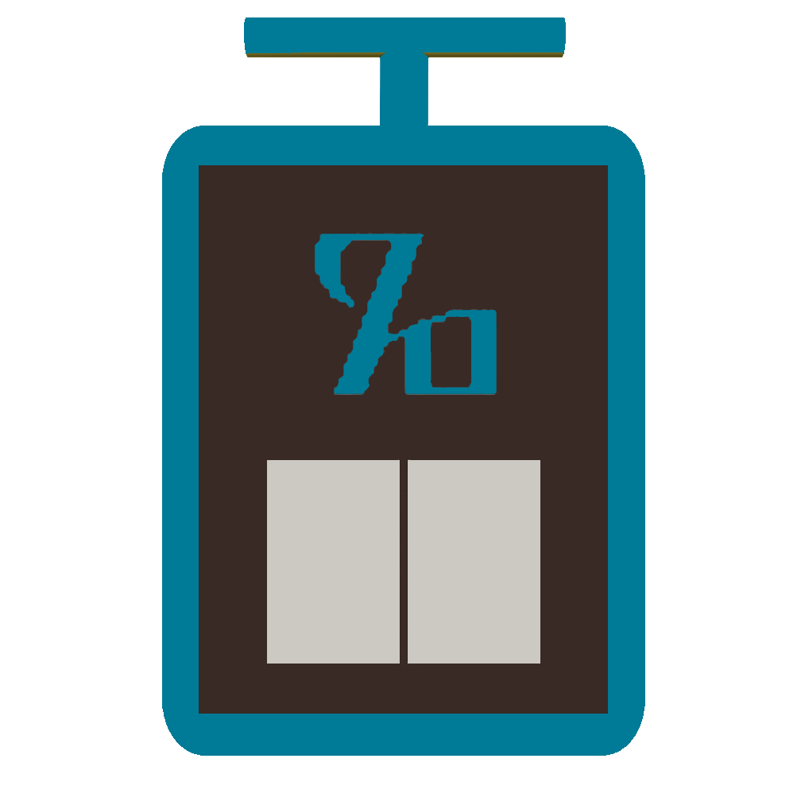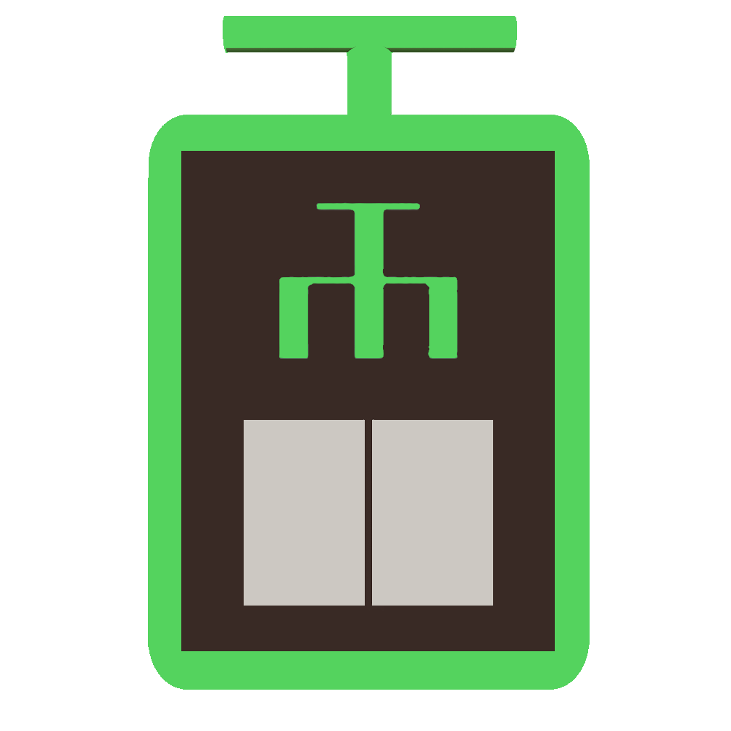

### Screen 4

Each trial will start with a short duration fixation screen, as shown below. During this time you should direct your fixation to the central fixation cross.

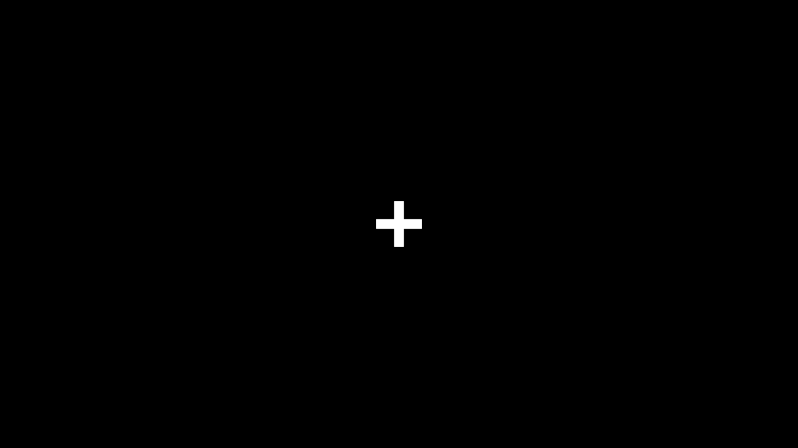

### Screen 5

Afterwards, you will be shown one of the four slot machines and a purchase price.

If you want to purchase and play the slot machine, press the LEFT arrow key.  
  
If you do not want to purchase it, press the RIGHT arrow key.

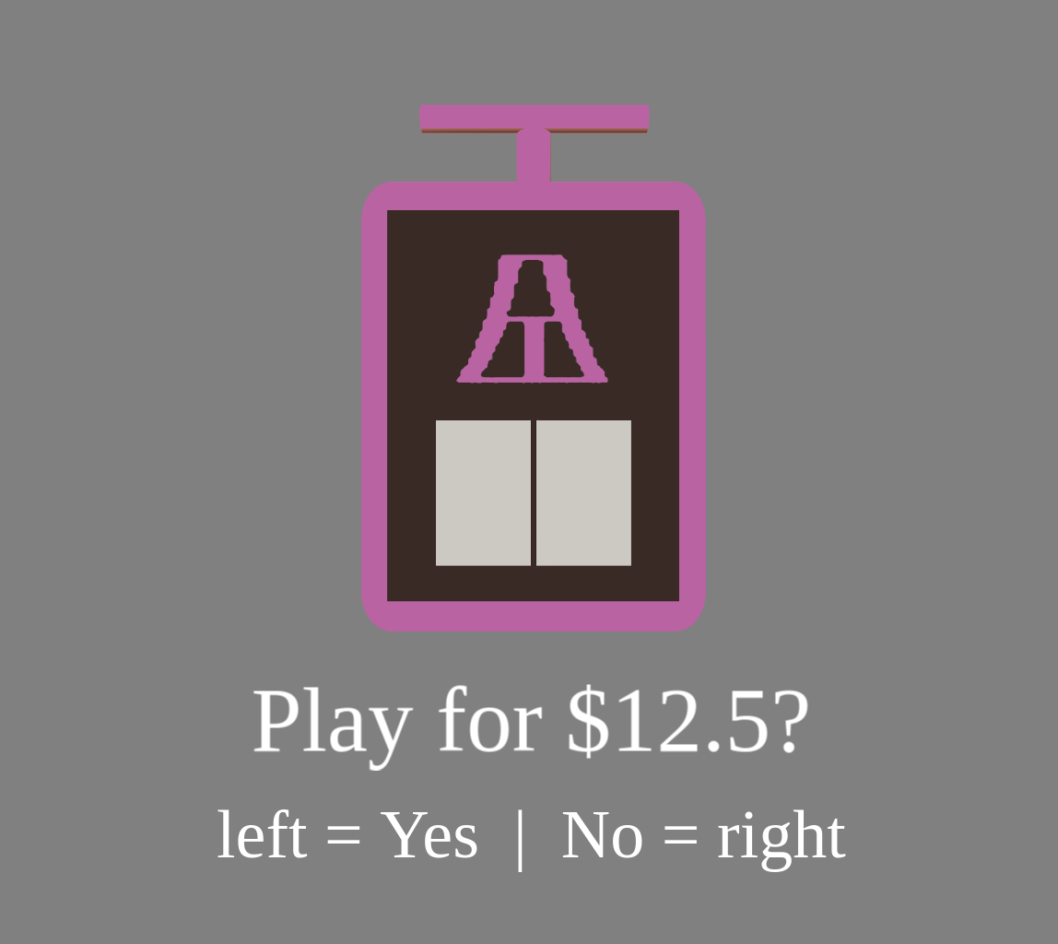

### Screen 6

Once you have made the choice, the computer will show you the outcome for the trial.

If you choose YES, the outcome shown is the overall earnings for the trial, given by the monetary prize MINUS the purchase price.

For example, if the purchase price is $10 and the slot machine gives a prize of $14.23, the outcome will be:

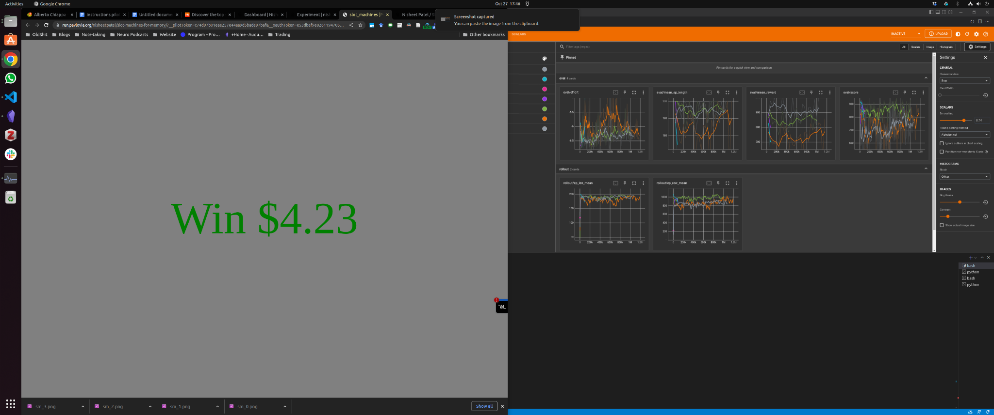

### Screen 7

Here is another example.  
  
If you choose YES, the purchase price is $10, and the slot machine gives a prize of $4.36, the screen will be:

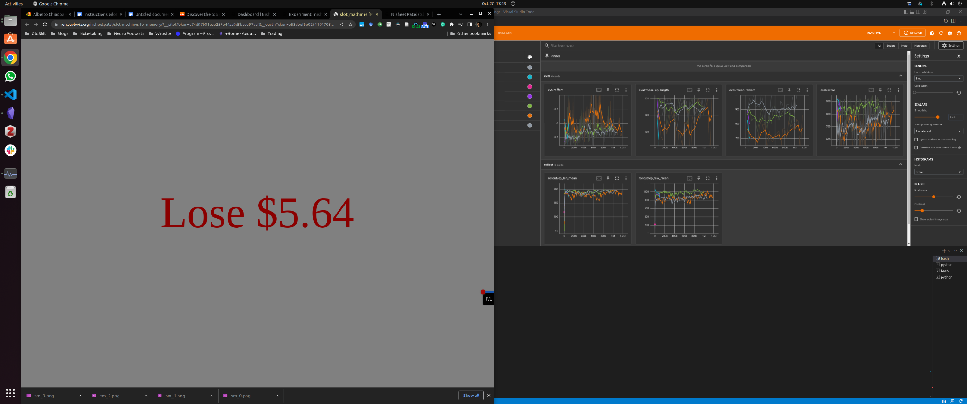

### Screen 8

If you chose NO, you don’t win or lose money in the trial, and the screen is:

(image missing but will add later)

### 

### 

### Screen 9

Here is more information about the experiment.

First, please make your choices as quickly as you feel comfortable doing so, and ideally under three seconds.

In order to help you do this, we will remind you to speed up if you take longer than three seconds to make a choice, using the following screen:

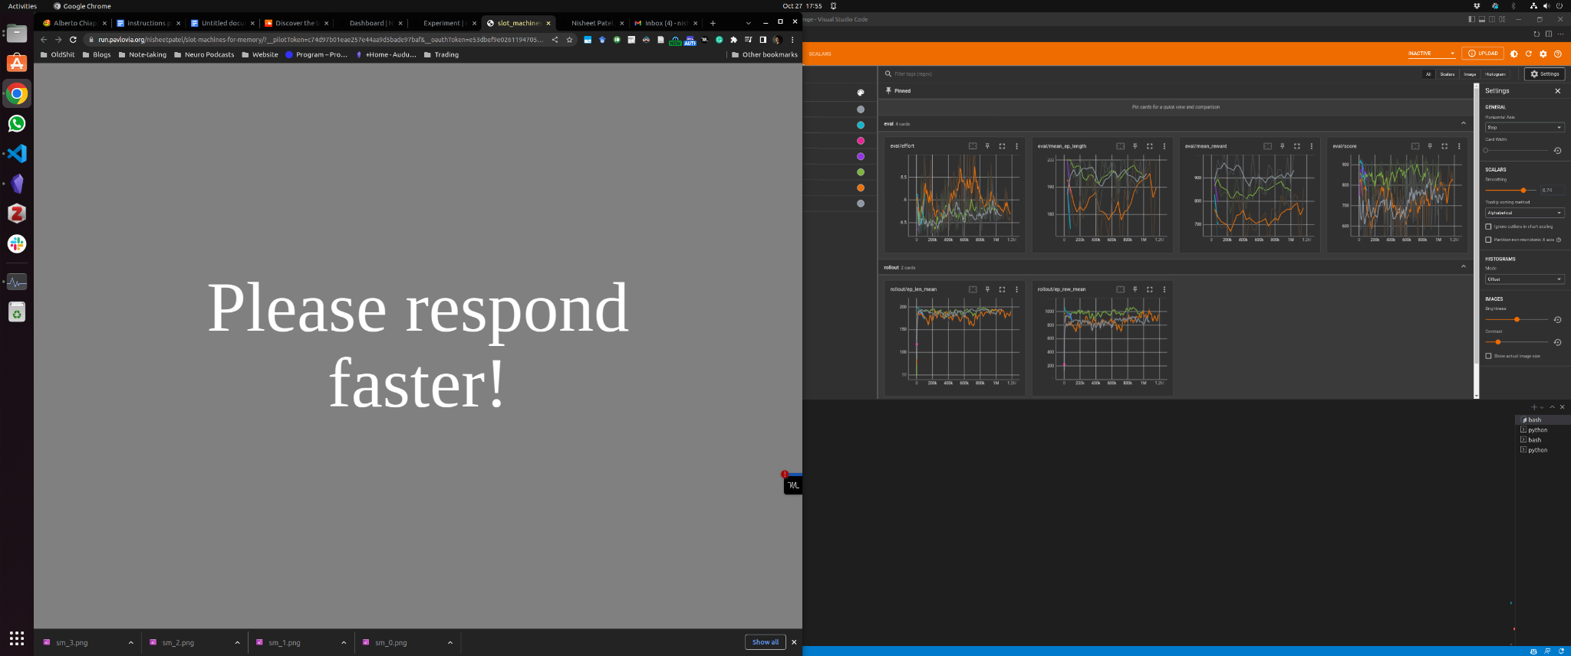

### Screen 10

Second, the experiment will take approximately 60 minutes to complete. To make the experience more enjoyable, we have divided the experiment into 4 blocks of about 200 decisions each.

We encourage you to take short breaks in between.

### Screen 11

At the beginning of the experiment, you will see the following screen, and you start the block by pressing any key on the keyboard:

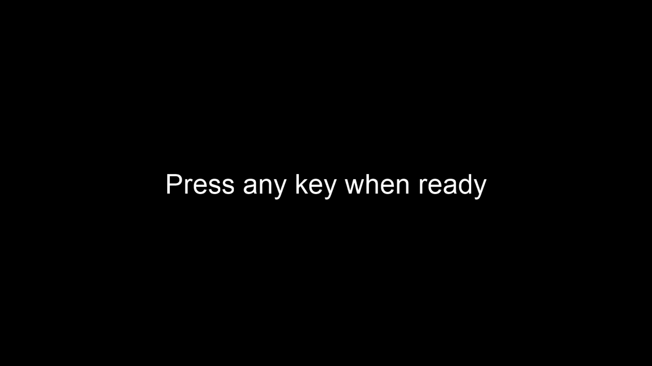

### Screen 12

At the end of each block you will see the following screen, please take a few moments to rest and when ready press any key to start the next block:

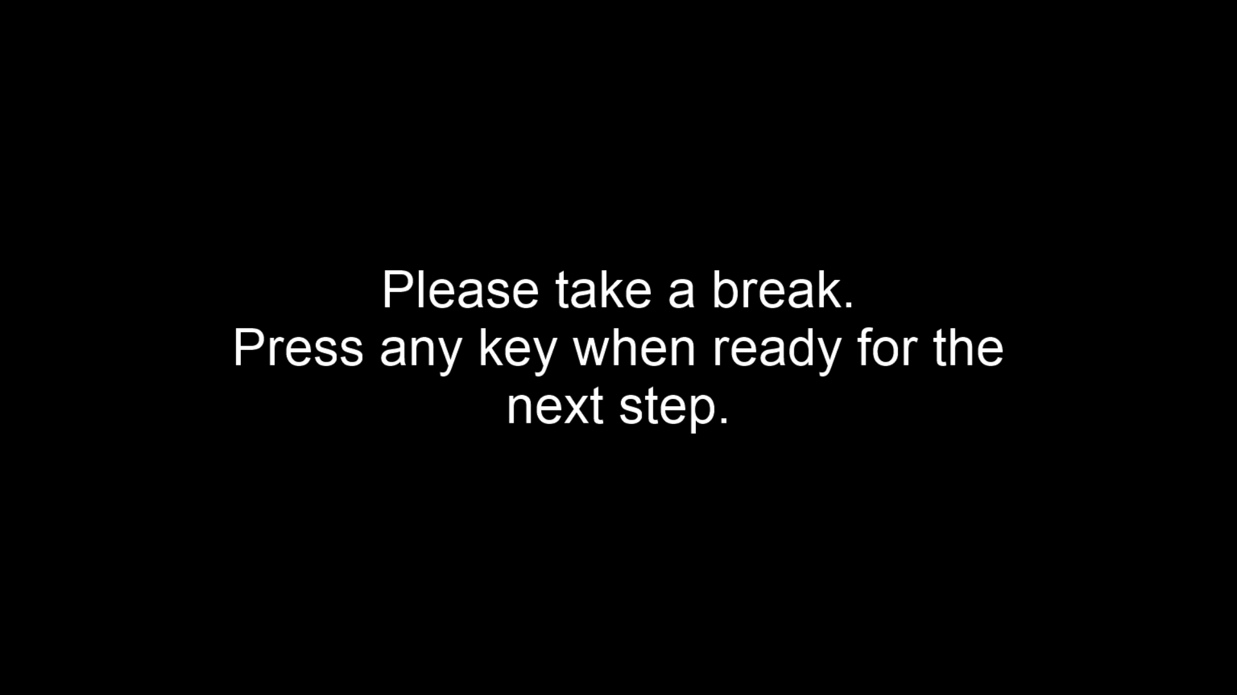

### Screen 13

What determines your final compensation for participating in the experiment?

You will receive a fee of $25 dollars for showing up and completing the experiment. In addition, the computer will randomly select two decision trials from each of the four blocks, and add the outcome of those trials to your overall earnings.

Note that under this rule only a small fraction of your decisions will affect your final earnings. However, since you don’t know in advance which decisions will count, your best strategy is to treat each decision as if it were one that counts, and make the best possible choice.

You will receive payment for your participation and performance in the experiment by inputting the completion code in your account.